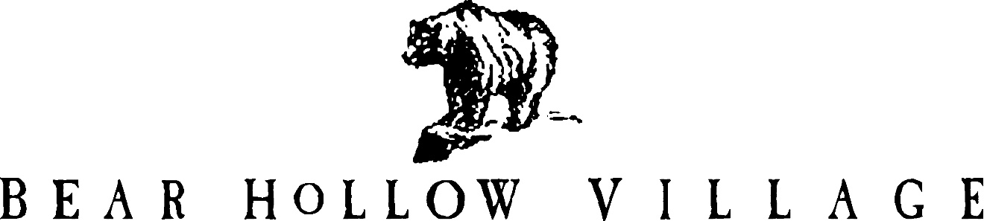

HOMEOWNER’S ASSOCIATION

PARK CITY, UTAH

NEWSLETTER

SUMMER 2021

This is the 49th edition of the Bear Hollow Village Homeowner’s Association Newsletter brought to you by your Board of Trustees. This Newsletter will provide you with an update on things happening in our community and other information.

**CLUBHOUSE – COVID 19**

We are maintaining a close watch on the Covid-19 pandemic situation in Summit County.

We strongly urge persons using any of the Clubhouse facilities to practice social distancing, continue to wear a face mask and practice safe hygiene. As of now, there are no mandatory mask or other requirements in effect. If conditions change we will adjust our guidelines accordingly and keep you updated.

We removed the rubber mats in the gym exercise area because they were very hard to keep clean

and their absorbency was a problem. We replaced some of the carpeting squares in the gym and we think keeping the carpet areas clean is a better option.

The maximum occupancy for the gym was reduced from 25 persons (which we felt was excessive and unrealistic) to 12 persons; a new sign indicating the change was posted in the gym.

**The pool will close for the season on Monday September 20, 2021.** The hot tub remains open, please be reminded the maximum capacity of the hot tub is 12 persons at any time.

The fire suppression system sprinklers and extinguishers were serviced and inspected in accordance with County requirements.

The metal railings by the steps at the front entrance are rusting and need replacement. We have contracted with Western Fence Company to have all necessary repairs completed as soon as possible.

We purchased new pool covers since the old ones were at the end of their useful life.

**VILLAGE GREEN**

In July, a 13year old boy visiting with his parents from Colorado, was injured while playing in the Green when one of the large boulders that line the perimeter of the Green was dislodged, fell and cut the boys leg. He was taken to a SLC hospital by ambulance and received 18 stitches to close the wound. There are no permanent injuries that we are aware of. This was an unfortunate accidental incident, the circumstances of exactly how it happened are unclear; the boy said he was sitting on the rock when it just came down on his leg. The boys parents have retained an attorney to represent them in this matter; to date no legal actions have been served on the HOA.

We have advised our liability insurance company provider, Travelers Insurance, of the matter and they have assigned a claims representative to monitor the case.

We are well insured in this matter, and more importantly, we did nothing that would reasonably be considered negligence or allowing an unsafe environment in the Green to exist. This was just an unfortunate accident.

We have placed KEEP OFF ROCKS signs in the 4 corners of the Green and we have installed a

new video camera on the roof of the office building overlooking the Green to allow us to better monitor activities in the area.

This would seem to be a good time to remind everyone that our community, like every other community / HOA, has rules and regulations in effect to ensure that all persons using our facilities are doing so in a safe and appropriate manner. Please be sure that your family members and guests are not doing things that they shouldn’t in our common areas for the benefit of us all.

The fire pit in the Green was out of service for a few weeks. The interior burner components broke and we had to special order parts and then line up a repair technician to make the needed repairs. The fire pit is now back in service, sorry for any inconvenience this may have caused.

**ASSOCIATION FINANCES**

We remain in excellent financial condition and have the following funds on deposit with Chase Bank, as of September 17, 2021 :

RESERVE FUND SAVINGS ACCOUNT $ 326,082.02

EMERGENCY FUND SAVINGS ACCOUNT $ 50,486.47

CHECKING ACCOUNT (operating capital) $ 32,177.28

TOTAL $ 408,745.77

**HIGH VALLEY TRANSIT SERVICES**

We would like to advise all Bear Hollow Village owners and residents of the new transit services now in effect thru High Valley Transit, offering fare-free fixed route and micro transit services

throughout the area and including Bear Hollow Village. This new service was launched on

July 1, 2021 and is available 365 days a year between 5AM and 1AM

For more info please visit their website [www.highvalleytransit.org](http://www.highvalleytransit.org)

**COMMUNITY SAFETY**

At the request of the HOA, the Summit County Sheriff has placed a speed monitoring / radar device in the community to remind us all to please slow down when driving. Sheriffs Deputies have also been asked to increase their presence in Bear Hollow while on patrol.

The speed limit on all our private roads designated as an “alley” has been reduced to 15 MPH.

New speed limit signs have been posted at each entry point to the following roads/ alleys –

Biathlon Loop Curling Court Cross Country Way

Freestyle Way Grizzly Way Kodiak Way

Polar Way Slalom Way Upper Luge Lane

Please be sure you are aware of and in compliance with the new speed limits when driving on these roads / alleys.

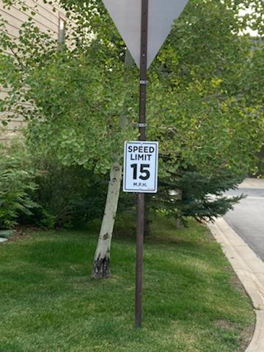

THANK YOU for your cooperation.

**IRRIGATION SYSTEM TURN OFF**

We will be shutting down the irrigation sprinkler system for the winter and all the lines need to be blown out and closed. All single family detached homes and the townhouses that have an irrigation control valve received a Notice from the HOA with instructions to turn the valve off by the deadline of October 4, 2021. If you have a valve in your property and you have not yet turned it off, please do so now. Follow the instructions on the Notice received if you need help.

**PROPERTY MAINTENANCE - UNSIGHTLINESS**

Please be reminded that the community rules, the CCRs, require all Owners to maintain the exterior of their property to reasonable / acceptable standards. Please inspect the exterior of your properties, especially the decks, logs and stairway areas and make any repairs or refinishing that is needed.

**HOA DESIGN REVIEW COMMITTEE**

Please be reminded that anything that will change the exterior of your property must be submitted to and reviewed / approved by the HOA Design Review Committee (DRC) as a first step. Send information describing the proposed project to Howie for processing by the DRC.

**PARKING RULES**

As we prepare for the coming winter season please be reminded of our community parking rules

that are posted on our website [www.bhvhoa.com](http://www.bhvhoa.com) and all posted no parking signs advising you where parking is not permitted. We do not like to tow away vehicles and we take all reasonable steps to attempt to notify the owner of a vehicle parked in violation of a parking rule.

However, any vehicle illegally parked so as to create a safety hazard or impeding snow removal operations will be towed away immediately. Please make sure your guests / property managers, renters are aware of the community Vehicle Rules and Regulations.

**ANNUAL MEETING**

Our 2021 Annual Meeting will be on Monday night December 6. 2021. We will again host the meeting via a Zoom webinar. You will receive more detailed information on the Annual Meeting later this year – this is just an advance notice.

The Annual Meeting will include the election of three HOA Trustees. Any owner wanting to be considered for election to the Board of Trustees should make their intentions known in accordance with the Trustee Election Guidelines accompanying this Newsletter.

******************************************

Please enjoy our amazing community and its amenities. Winter season is fast approaching we are all anxious to get back on the slopes to enjoy the beautiful mountain climate of Park City.

We love our snow - on the mountains – but not in our driveways !

Please stay safe and healthy and continue to practice social distancing.

Your HOA Board of Trustees!

GREG JODY HOWIE KAREN JOHN

MCj04360010000%5b1%5d MCj03474450000%5b1%5d **MCj01986060000%5b1%5d**



[This Photo](http://www.dpti.sa.gov.au/livingneighbourhoods/making-it-happen/action-planner) by Unknown Author is licensed under [CC BY](https://creativecommons.org/licenses/by/3.0/)



[This Photo](https://opentextbc.ca/abealf2/chapter/chapter-1/) by Unknown Author is licensed under [CC BY](https://creativecommons.org/licenses/by/3.0/)

PLEASE VISIT OUR WEBSITE

[WWW.BHVHOA.COM](http://www.bhvhoa.com/)



HOMEOWNER’S ASSOCIATION

PARK CITY, UTAH

POLICY STATEMENT

TRUSTEE ELECTION GUIDELINES

**PURPOSE:**

The following Guidelines for the election of Trustees are hereby established.

**AUTHORITY:**

In accordance with the Association By-Laws and Article 3.3 et.seq. of the Second Amended Restated and Confirmatory Declaration of Protective Covenants, Conditions, and Restrictions for Bear Hollow Village (CCR’s) the Board of Trustees for the Homeowners Association is empowered to promulgate Rules & Regulations for the proper and safe management of the community.

**THIS POLICY HEREBY ESTABLISHES THE FOLLOWING GUIDELINES FOR TRUSTEE ELECTIONS:**

* The HOA Board of Trustees is currently comprised of five members. In accordance with the CCR’s Trustees are elected for a two year term of office.

Trustee elections are staggered so terms of office do not all expire in one year.

* Trustee elections are held at the Annual Meeting of the Homeowners Association convened in early December (or any adjournment thereof).
* The HOA will announce Trustee vacancies in the Summer Newsletter sent to all Owners in the month of September.
* Owners seeking election to the Board of Trustees will be invited to send to the HOA President a notice of intent to seek nomination at the Annual Meeting. The notice must be received by the HOA President no later than October 15. A notice of intent sent / received after the cut off date will not be accepted / honored.
* Owners seeking election to the Board of Trustees can submit a brief statement of their qualifications or any other information they want mentioned on their behalf with regards to their candidacy for Trustee with their notice of intent. The information submitted must be received by the HOA President no later than October 15. Information sent / received after the cut off date will not be accepted / honored.
* Statements/information submitted by Trustee candidates must be submitted on plain white bond paper – size 12 font (any style) double spaced – 1 inch margins all around - maximum 1 page standard letter paper size. Statements / information

not submitted in accordance with these guidelines will be rejected.

* At least 30 days prior to the announced Annual Meeting date, the HOA will send all Owners in good standing a Notice of the Annual Meeting date and information on Trustee vacancies for that year.
* The Notice will include a Proxy Form for Owners to use to express their voting preference(s) for Trustee election and other matters. All candidates who have made their intention to run for Trustee known to the HOA by the October 15 deadline will be listed on the Proxy Form.
* The Notice of Annual Meeting sent to all Owners in good standing will also include any biography/information statements received from candidates in accordance with the guidelines established herein.
* Proxy forms submitted by Owners expressing their voting preferences for Trustee vacancies and any other matters listed on proxy form must be submitted to the HOA in accordance with the instructions noted on the proxy form.
* A Trustee voting form will be made available for all Owners attending the meeting in person. In person voting forms will supersede any prior proxy submitted by the Owner.
* At the Annual Meeting, one of the current Trustees not seeking election will preside over that portion of the Annual Meeting dealing with Trustee elections.
* At the Annual Meeting, all candidates for Trustee election must have their name placed into nomination by themselves or an Owner in good standing and seconded by an Owner in good standing.
* Any member of the HOA / Owner seeking candidacy for a Trustee position that has not previously submitted their name and biography/ information to the HOA for inclusion on the proxy voting form sent to all Owners prior to the Annual Meeting, or listed on the in person ballot, may have their name placed into nomination and be considered for election, but they have no recourse to request new proxy voting forms be created and sent to Owners which would include their name/information or to request any proxy not containing their name be voided.
* The Trustee presiding over the election will collect all ballots submitted by Owners in attendance at the meeting and all proxy forms sent in according to

the guidelines established for the election.

* The presiding Trustee will also solicit the assistance of another Owner in good standing to act as an independent observer to assist with the review and counting of all voting forms and proxy forms received.
* The presiding Trustee and assisting Owner will count all votes received and submit the results to the Board of Trustees along with a certification that all vote

ballots and proxy forms were reviewed and counted in a fair and impartial manner.

* The Board of Trustees will post the results of the Trustee election, within 24 hours of their receipt, on the HOA Clubhouse bulletin board and within 72 hours on the “Announcements” page of the HOA website.

These guidelines are hereby enacted and effective September 1, 2017.