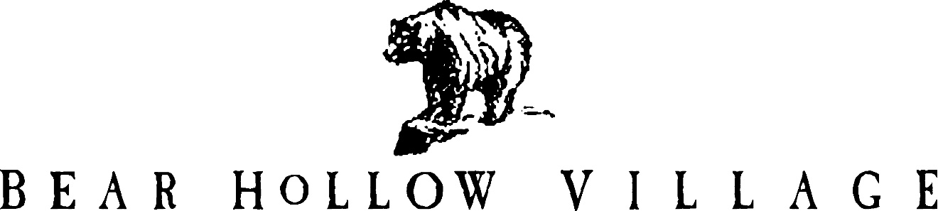

HOMEOWNER’S ASSOCIATION

PARK CITY, UTAH

NEWSLETTER

SUMMER 2020

This is the 47th edition of the Bear Hollow Village Homeowner’s Association Newsletter brought to you by your Board of Trustees. This Newsletter will provide you with an update on things happening in our community and other information.

**CLUBHOUSE – COVID 19**

Summit County remains in a low risk (Yellow) status regarding the Covid-19 Utah Phased Guidelines in effect. However, there are still concerns and safeguards that are mandated and

necessary. ALL persons entering the Clubhouse MUST wear a face mask – the only time you do not have to wear a face mask is when you are in the process of exercising in the gym.

(if you were to stop exercising and go to the rest room, for example, you would have to wear a mask to go).

As a safety precaution, we have installed an air purification system as an attachment to the building HVAC systems. Two units were installed. They will remove airborne and surface contaminants and pollutants including microbes, viruses, bacteria, allergens, dust, mold and smoke contaminants.

We have taped off several pieces of exercise equipment and limited occupancy in the gym area

to a maximum of 4 persons (in accordance with County guidelines and the square footage space of the gym room).

The pool will close for the season on or about Monday September 21st. We will also keep the hot tub closed during this time of the year when we do not staff the Clubhouse as a safety precaution (we do not believe the size of the hot tub is suitable for social distancing guidelines to be effectively maintained).

ALL owners and their tenants or guests MUST cooperate and comply with all posted notices regarding Covid-19 guidelines and requirements in effect for the Clubhouse. If you are planning to visit the Clubhouse please bring a face mask with you and WEAR IT.

In addition, in June we experienced a fire suppression sprinkler line break in the Great Room area of the Clubhouse. Water damage to the walls, insulation, carpeting and tile flooring in the room was sustained. We filed an insurance claim for the cleanup and repairs with our liability insurance carrier (Travelers Insurance). Alpine Cleaning and Restoration, a Utah disaster cleanup contractor, did a nice job of cleaning and restoring the Great Room to its pre damage state. All clean up and repairs (with the exception of 1 floor tile that was chipped) are completed

and the Great Room is available for usage and enjoyment (replacement tile on order).

The exterior wood trim areas around the doorways, windows and eaves of the Clubhouse were refinished. The lower portion of the “stone” columns around the Clubhouse exterior, which were

artificial stone and deteriorating badly, were replaced with natural stone and repaired.

**PRIVATE ROADS REPAIR & REPAVING PROJECT**

Summit County recently completed a resurfacing of Bobsled Blvd. and Oslo Lane, both County roads. We followed their lead and had all our private roads repaired or repaved as necessary. As the result, all community roads are looking good and are in great shape.

The total cost for the project was $190,870.04

We paid for the work as follows –

$170,000.00 was taken from our Reserve Savings Account

18,000.00 will not be deposited into our Reserve Account this year, instead

funds will pay for the repaving work

2,870.04 was used from the checking account/ General Operating capital

$190,870.04

**ASSOCIATION FINANCES**

We remain in excellent financial condition and have the following funds on deposit with Chase Bank, as of September 13, 2020 :

RESERVE FUND SAVINGS ACCOUNT $ 299,021.04

EMERGENCY FUND SAVINGS ACCOUNT $ 50,466.53

CHECKING ACCOUNT (operating capital) $ 38,957.56

TOTAL $ 388,445.13

**INFRASTRUCTURE REPAIRS / MAINTENANCE**

The following areas in the community were cleaned and refinished :

* The wood columns at the mail kiosk building
* The wood railings for the Bobsled Bridge
* The wood split rail fencing on Bobsled Blvd.

The artificial stone along the base of the kiosk building was also replaced with natural stone.

**IRRIGATION SYSTEM TURN OFF**

We will be turning off the irrigation sprinkler system in first week of October. All single family detached homes and the townhouses that have an irrigation control valve will receive a

Notice from the HOA with instructions to turn the valve off. If you do not receive a Notice you do not have a valve.

**RECYCLING - TRASH COLLECTION**

Household trash collection services are provided by Republic Services. Trash and recycling services are provided by the County and paid for as part of your property tax. The County has provided all properties / owners with a trash container. Only trash put in the container is picked up on our regularly scheduled collection day - Tuesday weekly. Trash placed outside the container will not be picked up.

Summit County also provides curbside recycling for our community and a specific recycling container is also provided. You must NOT co-mingle trash with recyclables, it will not be picked up and creates a nuisance / mess in the community. All owners / residents are asked to familiarize themselves with trash and recycling rules and follow the guidelines established.

**If you have RENTERS in your property or use a RENTAL MANAGEMENT COMPANY to manage your property, please ensure this information is provided to them.**

**HOA DESIGN REVIEW COMMITTEE**

Please be reminded that anything that will change the exterior of your property must be submitted to and reviewed / approved by the HOA Design Review Committee (DRC) as a first step. Send information describing the proposed project to any of your Trustees for processing by the DRC.

**PROPERTY MAINTENANCE - UNSIGHTLINESS**

Please be reminded that the community rules, the CCRs, require all Owners to maintain the exterior of their property to reasonable / acceptable standards. Now would also be a good time to check your property exterior areas and prepare for winter. If you do not have HEAT TAPE or HEAT PANELS on your roof edges we would strongly urge you to have them installed to protect your roof and home from ice buildup and damages.

**PARKING RULES**

The community rules (the CCR’s) prohibit the parking of motor homes, recreational vehicles, boats/trailers, snowmobiles, trucks larger than a pickup truck, campers, inoperable vehicles and farm equipment ANYWHERE in Bear Hollow Village. This includes Bobsled Blvd and Oslo Lane, even though they are County Roads they are still IN Bear Hollow Village and subject to the CCR rules.

Signs are posted at each community entry corridor advising residents of the rules and the entire

Vehicle Rules & Regulations Policy is on our website for viewing. We do not like to tow vehicles, but we also do not want the community to become a long term parking lot for these

items.

We recognize that there will be times that our residents will need to have access to their RV

or boat, etc. to prepare for or clean up after it is used; we ask that you notify the Trustees if you have a need to bring your RV or boat, etc. into the community for a short term stay (24 hours).

We will have some flexibility and grant short term parking if requested.

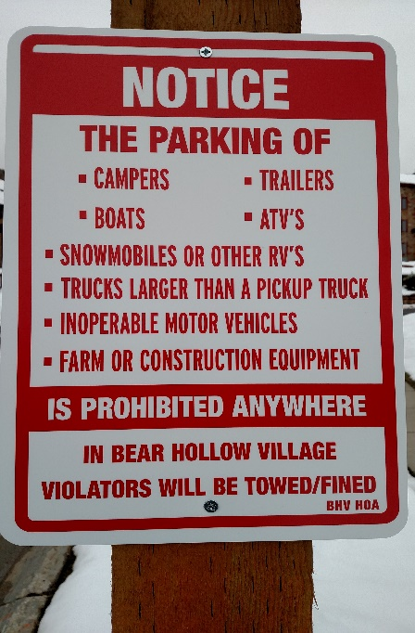

**COMMUNITY SAFETY**

We have many children in our community, but NONE to spare! We are asking all

community residents to PLEASE SLOW DOWN when driving in Bear Hollow Village.

We have posted Please Slow Down signs in the area of the Bobsled Park.

Your cooperation is most appreciated.

**LANDSCAPING -TREE’S**

This has been a tough year on the tree’s in the community. The HOA had Park City Tree Service perform 3 separate tree treatments / fertilizations of the tree’s to combat insect damage and promote healthy growth. Some tree’s have fared better than others. Please be reminded

that landscaping services and responsibilities to your private property areas are a shared responsibility between the owner and the HOA.

**2020 ANNUAL MEETING**

Our 2020 Annual Meeting has been scheduled for Monday December 7, 2020 in the Clubhouse.

We will send all owners an information package for the meeting in early November.

The Annual Meeting will include the election of two HOA Trustees. Any owner wanting to be considered for election to the Board of Trustees should make their intentions known in accordance with the Trustee Election Guidelines accompanying this Newsletter.

Please enjoy our amazing community and its amenities. Winter season is approaching and snow will be in the air, and everywhere else (including our driveways !) Get those legs in shape for the slopes, stay healthy and continue to practice social distancing, we will get thru this.

Your HOA Board of Trustees!

GREG JODY HOWIE SUSAN DOUG

MCj04360010000%5b1%5d MCj03474450000%5b1%5d **MCj01986060000%5b1%5d** 



[This Photo](https://opentextbc.ca/abealf2/chapter/chapter-1/) by Unknown Author is licensed under [CC BY](https://creativecommons.org/licenses/by/3.0/)

PLEASE VISIT OUR WEBSITE

[WWW.BHVHOA.COM](http://www.bhvhoa.com/)



HOMEOWNER’S ASSOCIATION

PARK CITY, UTAH

POLICY STATEMENT

TRUSTEE ELECTION GUIDELINES

**PURPOSE:**

The following Guidelines for the election of Trustees are hereby established.

**AUTHORITY:**

In accordance with the Association By-Laws and Article 3.3 et.seq. of the Second Amended Restated and Confirmatory Declaration of Protective Covenants, Conditions, and Restrictions for Bear Hollow Village (CCR’s) the Board of Trustees for the Homeowners Association is empowered to promulgate Rules & Regulations for the proper and safe management of the community.

**THIS POLICY HEREBY ESTABLISHES THE FOLLOWING GUIDELINES FOR TRUSTEE ELECTIONS:**

* The HOA Board of Trustees is currently comprised of five members. In accordance with the CCR’s Trustees are elected for a two year term of office.

Trustee elections are staggered so terms of office do not all expire in one year.

* Trustee elections are held at the Annual Meeting of the Homeowners Association convened in early December (or any adjournment thereof).
* The HOA will announce Trustee vacancies in the Summer Newsletter sent to all Owners in the month of September.
* Owners seeking election to the Board of Trustees will be invited to send to the HOA President a notice of intent to seek nomination at the Annual Meeting. The notice must be received by the HOA President no later than October 15. A notice of intent sent / received after the cut off date will not be accepted / honored.
* Owners seeking election to the Board of Trustees can submit a brief statement of their qualifications or any other information they want mentioned on their behalf with regards to their candidacy for Trustee with their notice of intent. The information submitted must be received by the HOA President no later than October 15. Information sent / received after the cut off date will not be accepted / honored.
* Statements/information submitted by Trustee candidates must be submitted on plain white bond paper – size 12 font (any style) double spaced – 1 inch margins all around - maximum 1 page standard letter paper size. Statements / information

not submitted in accordance with these guidelines will be rejected.

* At least 30 days prior to the announced Annual Meeting date, the HOA will send all Owners in good standing a Notice of the Annual Meeting date and information on Trustee vacancies for that year.
* The Notice will include a Proxy Form for Owners to use to express their voting preference(s) for Trustee election and other matters. All candidates who have made their intention to run for Trustee known to the HOA by the October 15 deadline will be listed on the Proxy Form.
* The Notice of Annual Meeting sent to all Owners in good standing will also include any biography/information statements received from candidates in accordance with the guidelines established herein.
* Proxy forms submitted by Owners expressing their voting preferences for Trustee vacancies and any other matters listed on proxy form must be submitted to the HOA in accordance with the instructions noted on the proxy form.
* A Trustee voting form will be made available for all Owners attending the meeting in person. In person voting forms will supersede any prior proxy submitted by the Owner.
* At the Annual Meeting, one of the current Trustees not seeking election will preside over that portion of the Annual Meeting dealing with Trustee elections.
* At the Annual Meeting, all candidates for Trustee election must have their name placed into nomination by themselves or an Owner in good standing and seconded by an Owner in good standing.
* Any member of the HOA / Owner seeking candidacy for a Trustee position that has not previously submitted their name and biography/ information to the HOA for inclusion on the proxy voting form sent to all Owners prior to the Annual Meeting, or listed on the in person ballot, may have their name placed into nomination and be considered for election, but they have no recourse to request new proxy voting forms be created and sent to Owners which would include their name/information or to request any proxy not containing their name be voided.
* The Trustee presiding over the election will collect all ballots submitted by Owners in attendance at the meeting and all proxy forms sent in according to

the guidelines established for the election.

* The presiding Trustee will also solicit the assistance of another Owner in good standing to act as an independent observer to assist with the review and counting of all voting forms and proxy forms received.
* The presiding Trustee and assisting Owner will count all votes received and submit the results to the Board of Trustees along with a certification that all vote

ballots and proxy forms were reviewed and counted in a fair and impartial manner.

* The Board of Trustees will post the results of the Trustee election, within 24 hours of their receipt, on the HOA Clubhouse bulletin board and within 72 hours on the “Announcements” page of the HOA website.

These guidelines are hereby enacted and effective September 1, 2017.