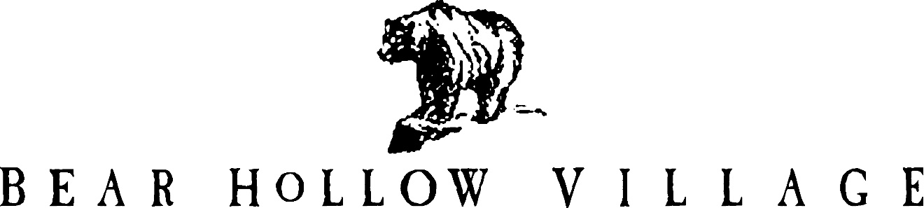

HOMEOWNER’S ASSOCIATION

PARK CITY, UTAH

NEWSLETTER

SPRING 2022

This is the 50thedition of the Bear Hollow Village Homeowner’s Association Newsletter brought to you by your Board of Trustees. This Newsletter will provide you with an update on things happening in our community and other information.

**REINVESTMENT FEE**

Voting on this issue is complete and Owners have overwhelmingly approved the creation of a reinvestment fee of one quarter of 1% (.0025) on the sale price of a property to be charged to a buyer when a property sells.

A total of 197 votes were received; 155 yes votes in favor of the fee and 42 no votes.

(There are 277 votes in the HOA and 142 (51%) were needed for approval.)

Our HOA attorney completed an Amendment document for our CCRs allowing the imposition of the fee and a Notice of Reinvestment Fee Covenant document to actually implement the fee.

Both documents were recorded with the Summit County Recorders Office and they are also posted on the HOA website.

The HOA created a Reinvestment Fee Form to assist in collecting the fee at a property closing.

This form is also posted on the HOA website.

**CLUBHOUSE**

We are planning to refinish the concrete edging around the pool and hot tub. A contractor has been hired and the work is scheduled for mid May. We are trying to get the work done before the pool opens for the summer season, scheduled for May 27. The work is contingent on the weather cooperating; we need the temperature to stay above 60 degrees during the day and overnight when the work is done so the finishing cures properly.

If we cannot schedule for May we will postpone the work until sometime in June. The pool and hot tub will need to be closed when the work is in progress. We will keep any closure to a minimum but we also want the finished product to look its best. If the work is completed in May as now scheduled we will only have to close the hot tub since the pool will not yet be open.

**Pool and Village Green Barbecue grills opening May 27.**

The soda vending machine inside the Clubhouse has “died” after serving diligently for many years. Due to the age of the machine we could not get any parts to attempt repairs. We have contracted with a Coca Cola vendor who will supply a new modern machine and all products.

The vendor will also be responsible for any maintenance the machine might require. We will receive a commission on all sales. The new machine is on order and will be in place shortly.

The candy / snack vending machine has also been replaced with a new, modern vending machine. A separate vendor has already placed a new machine in the Clubhouse and it is ready

for use. The vendor will have full responsibility for maintenance of the machine and will supply all the products offered for sale. We will receive a commission on all sales.

**ASSOCIATION FINANCES**

We remain in excellent financial condition and have the following funds on deposit with Chase Bank, as of April 25, 2022 :

RESERVE FUND SAVINGS ACCOUNT $ 347,103.51

EMERGENCY FUND SAVINGS ACCOUNT $ 50,469.80

CHECKING ACCOUNT (operating capital) $ 64,478.66

TOTAL $ 462,051.97

**BACK FLOW VALVE INSPECTIONS**

Summit Water Distribution Company is again notifying all residents that an annual inspection of the backflow valve in your home is required. The backflow valve is part of your fire suppression and/or irrigation system and is located inside your home, usually in a mechanical room or closet. A certified backflow technician must perform the inspection and proof of the inspection must be forwarded to Summit Water by the deadline indicated on your Notice. Please be sure you meet the deadline and have your backflow valve inspected as required.

**IRRIGATION SYSTEM TURN ON**

We will be turning on the irrigation sprinkler system for the spring / summer and all the lines need to be opened and repairs to the system completed as needed. All single family detached homes and the townhouses that have an irrigation control valve received a Notice from the HOA with instructions to turn the valve on by the deadline of May 3, 2022. Follow the instructions on the Notice received if you need help.

We are cognizant that there are drought conditions throughout Utah. Summit Water Company will probably initiate water restrictions for the coming season. We will be in compliance with any mandates received and will closely monitor our irrigation water usage.

**REMINDERS**

**COMMUNITY SAFETY**

The speed limit on all our private roads designated as an “alley” has been reduced to 15 MPH.

New speed limit signs have been posted at each entry point to the following roads/ alleys –

Biathlon Loop Curling Court Cross Country Way

Freestyle Way Grizzly Way Kodiak Way

Polar Way Slalom Way Upper Luge Lane

Please be sure you are aware of and in compliance with the new speed limits when driving on these roads / alleys. THANK YOU for your cooperation.

**PROPERTY MAINTENANCE - UNSIGHTLINESS**

Please be reminded that the community rules, the CCRs, require all Owners to maintain the exterior of their property to reasonable / acceptable standards. Please inspect the exterior of your properties, especially the decks, logs and stairway areas and make any repairs or refinishing that is needed.

**HOA DESIGN REVIEW COMMITTEE**

Please be reminded that anything that will change the exterior of your property must be submitted to and reviewed / approved by the HOA Design Review Committee (DRC) as a first step. Send information describing the proposed project to Howie for processing by the DRC.

To the disturbance will

**PARKING RULES**

All of our community parking rules are posted on our website [www.bhvhoa.com](http://www.bhvhoa.com) and signs are posted advising you where parking is not permitted. We do not like to tow away vehicles and we take all reasonable steps to attempt to notify the owner of a vehicle parked in violation of a parking rule. However, any vehicle illegally parked so as to create a safety hazard will be towed away immediately. Please make sure your guests / property managers, renters are aware of the community Vehicle Rules and Regulations.

**NOISE ORDINANCE**

The Summit County Noise Ordinance 5-3-1 and the community rules prohibit the creation of unreasonable noise after 9PM. Any property creating unreasonable noise after 9PM in violation of the Ordinance that results in a Sheriffs Deputy having to respond will be subject to a fine imposed by the Board of Trustees and suspension of owner privileges as deemed necessary.

Please ensure that any renters in your property are aware of the Ordinance. YOU are responsible

for their actions while they are in the community.

**PETS POLICY**

The Summit County Animal Control Ordinance and the HOA Pets policy require that all pets be under the control of their responsible person while outdoors. Pet droppings MUST BE PICKED UP immediately after they are made.

In addition, the community rules limit the number of dogs or cats allowed in a property to two (2). Short term / Nightly renters ( renting less than 30 days) are prohibited from having pets at any time.

The HOA will impose severe fines on any Owner identified as being in violation of the Pets Policy.

******************************************

Please enjoy our amazing community and its amenities. Summer season is fast approaching and we are all anxious to get outdoors and appreciate the beautiful mountain climate of Park City.

Please stay safe and healthy and continue to practice social distancing.

Your HOA Board of Trustees!

GREG JODY HOWIE KAREN JOHN

MCj04360010000%5b1%5d MCj03474450000%5b1%5d **MCj01986060000%5b1%5d**



[This Photo](http://www.dpti.sa.gov.au/livingneighbourhoods/making-it-happen/action-planner) by Unknown Author is licensed under [CC BY](https://creativecommons.org/licenses/by/3.0/)



[This Photo](https://opentextbc.ca/abealf2/chapter/chapter-1/) by Unknown Author is licensed under [CC BY](https://creativecommons.org/licenses/by/3.0/)

PLEASE VISIT OUR WEBSITE

[WWW.BHVHOA.COM](http://www.bhvhoa.com/)