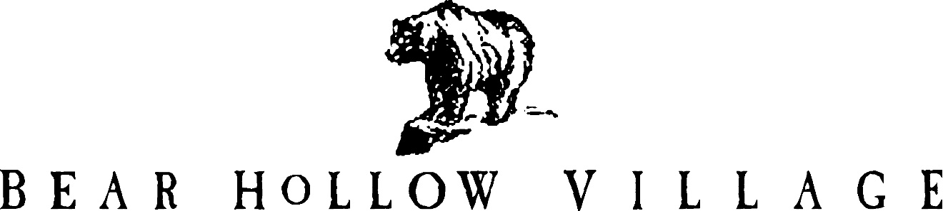

HOMEOWNER’S ASSOCIATION

PARK CITY, UTAH

NEWSLETTER

SPRING 2021

This is the 48th edition of the Bear Hollow Village Homeowner’s Association Newsletter brought to you by your Board of Trustees. This Newsletter will provide you with an update on things happening in our community and other information.

**CLUBHOUSE – COVID 19**

Summit County remains in a low risk (Yellow) status regarding the Covid-19 Utah Phased Guidelines in effect. It is no longer mandatory to wear a face mask when in the Clubhouse.

We strongly urge persons using any of the Clubhouse facilities to practice social distancing, continue to wear a face mask and practice safe hygiene.

We have opened for use all of the exercise equipment in the gym.

The pool is now open for the season. We have limited the amount of lounge chairs placed around the pool and in the adjoining patio area to help maintain proper social distancing between

persons / groups. The hot tub is open, please be reminded the maximum capacity of the hot tub is 12 persons at any time.

As a safety precaution and reminder, we have installed an air purification system as an attachment to the building HVAC systems. Two units were installed. They will remove airborne and surface contaminants and pollutants including microbes, viruses, bacteria, allergens, dust, mold and smoke contaminants.

We are closely monitoring national and Summit County health recommendations and will adjust Clubhouse amenities with the best interests of the community in mind.

The barbecue grills and patios in the Village Green are opened and available for your use. Please be reminded that you need to use your Clubhouse access card to swipe and start the grills for use.

**POLICY REVISIONS**

The Board of Trustees have enacted revisions to the following community Policies / Rules:

* Property Registration Policy
* Landscape Services Policy
* Vehicle Rules & Regulations Policy
* Clubhouse Policy

The changes to each Policy are summarized as follows:

PROPERTY REGISTRATION POLICY -

**7. Owners are specifically reminded that the Summit County Noise Ordinance**

**(5-3-1) specifically prohibits excessive noise between the hours 9:00PM and**

**7:00AM MST. The entire Ordinance is posted on the HOA website**

[**www.bhvhoa.com**](http://www.bhvhoa.com) **for review. All Owners and their renters are expected to be**

**fully aware of the Ordinance and in compliance with it at all times.**

**8. Owners renting their properties on a Property Rented / Short Term Basis via AIRBNB, VRBO or other similar web based services must have a designated emergency contact person / local person who is a resident of the State of Utah and located within 1 hours drive of Bear Hollow Village ( within 50 miles) or a professional property management company available to respond to any emergency or complaints associated with their Bear Hollow Village property while rented. The designated emergency contact person or property management company representatives name/address/contact phone #/contact email must be provided to the HOA as part of their property registration form.**

LANDSCAPE SERVICES POLICY –

**The Homeowner’s Association will provide mulch to Owners properties on a bi-annual basis (every other year). Properties north of the Clubhouse will receive mulch in even numbered years and properties south of the Clubhouse will receive mulch in odd numbered years. Mulch will only be provided to the front and / or rear areas of an Owners residence that faces the street. Mulch to areas on the sides of a property are an Owner’s responsibility. Mulching will be provided subject to available funds and at the sole discretion of the Board of Trustees.**

VEHICLE RULES & REGULATIONS POLICY –

**No parking any time on the south and east sides of Upper Luge Lane**

**No parking any time in the emergency vehicle turn around area on Upper Luge Lane**

**No parking any time by the entrance to the lower walkway steps near 5438 Luge Lane - road painted with stripes designating no parking.**

CLUBHOUSE POLICY –

**3A. Clubhouse access cards remain the property of the BHVHOA at all**

**times.  An Owner who sells their Bear Hollow Village home must**

**surrender all their issued Clubhouse access cards to the HOA at the**

**time of sale / closing.**

**3B.     All persons using a Clubhouse access card must be using a card**

**specifically issued to the property they own or are renting.  Any**

**person using a Clubhouse access card that is not registered /**

**issued to their property will have the card confiscated by the HOA.**

In the ENFORCEMENT area - **An owner who has Clubhouse access privileges suspended for a Policy violation will be subject to a reinstatement fee to have their Clubhouse card(s) re-activated.**

All community rules / Policies are posted on our website [www.bhvhoa.com](http://www.bhvhoa.com) for

viewing at any time.

**ASSOCIATION FINANCES**

We remain in excellent financial condition and have the following funds on deposit with Chase Bank, as of May 30, 2021 :

RESERVE FUND SAVINGS ACCOUNT $ 317,065.75

EMERGENCY FUND SAVINGS ACCOUNT $ 50,483.88

CHECKING ACCOUNT (operating capital) $ 94,366.44

TOTAL $ 461,916.07

**BACKFLOW VALVE INSPECTION**

Summit Water Distribution Company has notified all residents that an inspection of the backflow valve in your home is required. The backflow valve is part of your fire suppression and/or irrigation system and is located inside your home, usually in a mechanical room or closet.

A certified backflow technician must perform the inspection and proof of the inspection must be forwarded to Summit Water by the **deadline July 15, 2021**. Please be sure you meet the deadline and have your backflow valve inspected as required.

**IRRIGATION SYSTEM TURN ON**

We are in the process of turning on the irrigation sprinkler system . All single family detached homes and the townhouses that have an irrigation control valve received a Notice from the HOA with instructions to turn the valve on. If you have a valve in your property and you have not yet turned it on, please do so now.

**RECYCLING – TRASH COLLECTION**

Household trash collection services are provided by Republic Services. Trash and recycling services are provided by the County and paid for as part of your property tax. The County has provided all properties / owners with a trash container. Only trash put in the container is picked up on our regularly scheduled collection day – Tuesday weekly. Trash placed outside the container will not be picked up.

Summit County also provides curbside recycling for our community and a specific recycling container is also provided. You must NOT co-mingle trash with recyclables, it will not be picked up and creates a nuisance / mess in the community. All owners / residents are asked to familiarize themselves with trash and recycling rules and follow the guidelines established.

**If you have RENTERS in your property or use a RENTAL MANAGEMENT COMPANY to manage your property, please ensure this information is provided to them.**

**SNYDERVILLE BASIN PLANNING COMMISSION - MEETING**

The Snyderville Basin Planning Commission convened a meeting on May 11, 2021 via Zoom webinar to consider a request by the Rocky Mountain Power Company who are requesting permission to proceed with replacing approximately 50 power line poles within the Snyderville Basin district. On behalf of the community, Howie logged in to the Zoom webinar to monitor the event. Here is a summary of the presentation and discussion:

* As part of their wildfire fire safety upgrade initiative Rocky Mtn. Power wants to replace 50 poles in the district area. The power line runs from the Park City area and thru their Bear Hollow substation area (behind and above Grizzly Way on west side of our community). There are 6 poles behind our community that will be replaced. The new poles will be 75 feet high and made of steel. The older poles being replaced are wood and 59 feet high. The extra height meets current fire safety standards and will allow for greater distance between the transmission lines to meet current fire code standards. The steel poles will be colored to blend in with the native appearance of the area as best possible.
* The Summit County Planning Department provided a report that favorably recommended approval of the request.
* Rocky Mtn. Power advised that the project would commence in the Spring of 2022 if approved by the Commission and the County.
* The Commissioners asked if it was possible to put the transmission lines underground. Lisa Romney, Rocky Mtn. Power Regional Manager replied it is cost prohibitive to move the lines underground (it costs $300,000 per mile for above ground poles and $6.2 million per mile for underground lines).
* There were no other significant questions or comments expressed.

The Commissioners voted to approve this request.

**PATHWAY PROJECT**

We are in the process of creating a pathway from Bobsled Blvd. to the millennium trail behind Cross Country Way. The path will be a gravel type material called “chat”. The sides of the path will be outlined with stone and the top and bottom areas of the trail where it meets Bobsled Blvd. and the trail will be highlighted by decorative boulders and mulch on each side.

We should be done with the project shortly – here is a photo of the new pathway now.

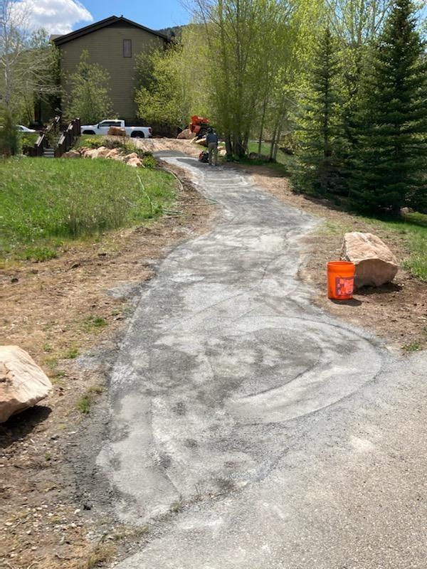

**COMMUNITY SAFETY**

We have many children in our community, but NONE to spare! We are asking all

community residents to PLEASE SLOW DOWN when driving anywhere in Bear Hollow Village. We have posted Please Slow Down signs in the area of the Bobsled Park. Your cooperation is most appreciated.

**PROPERTY MAINTENANCE - UNSIGHTLINESS**

Please be reminded that the community rules, the CCRs, require all Owners to maintain the exterior of their property to reasonable / acceptable standards. Please inspect the exterior of your properties, especially the decks, logs and stairway areas and make any repairs or refinishing that is needed.

**HOA DESIGN REVIEW COMMITTEE**

Please be reminded that anything that will change the exterior of your property must be submitted to and reviewed / approved by the HOA Design Review Committee (DRC) as a first step. Send information describing the proposed project to Howie for processing by the DRC.

**INSURANCE ON YOUR PROPERTY – TOWNHOUSES**

For the benefit of our new townhouse owners, and as a reminder to all our townhouse owners please be aware of the following information…

* Bear Hollow Village is NOT a condominium community, we are a planned unit development (PUD). Each townhouse owner owns the land their portion of the building sits on and everything from center stud to center stud, floor to roof, in their portion of the building. Saying that another way, there is no common area in a townhouse building; everything is someone’s private property and must be insured as such.
* The HOA provides NO insurance to any portion of your townhouse unit; HOA insurance covers ONLY the common areas of the community.
* Please make sure that you have your townhouse properly insured.

**PARKING RULES**

The community rules (the CCR’s) prohibit the parking of motor homes, recreational vehicles, boats/trailers, snowmobiles, trucks larger than a pickup truck, campers, inoperable vehicles and farm equipment ANYWHERE in Bear Hollow Village. This includes Bobsled Blvd and Oslo Lane, even though they are County Roads they are still IN Bear Hollow Village and subject to the CCR rules.

Signs are posted at each community entry corridor advising residents of the rules and the entire

Vehicle Rules & Regulations Policy is on our website for viewing. We do not like to tow vehicles, but we also do not want the community to become a long term parking lot for these

items.

We recognize that there will be times that our residents will need to have access to their RV

or boat, etc. to prepare for or clean up after it is used; we ask that you notify the Trustees if you have a need to bring your RV or boat, etc. into the community for a short term stay (24 hours).

We will have some flexibility and grant short term parking if requested.

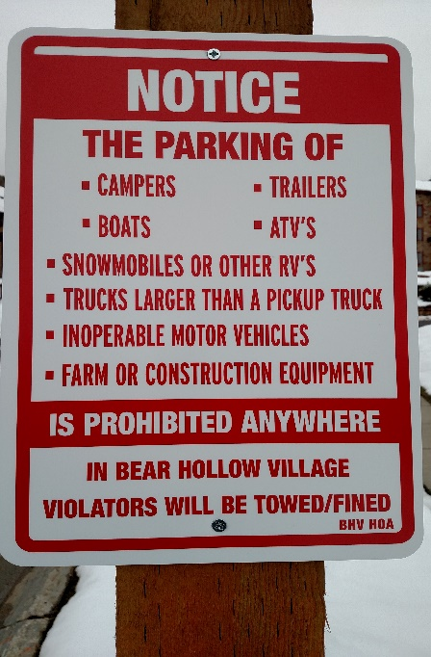

**NEW TRUSTEE**

Trustee Susan Worthington recently resigned her Trustee position and the Board of Trustees appointed owner Karen Malm to fill her unexpired term of office. Here is a brief introduction of Karen…..

KAREN MALM – TRUSTEE

Karen has been a full time resident in Bear Hollow Village since 2008.   Originally from New York, she moved to Utah in 1979 to spend her “junior year in college abroad” and never left.  With assistance from the Mountainlands Community Housing Trust organization she was able to purchase an affordable townhouse unit in Bear Hollow and raise her two children through the Park City school system.  Karen is a licensed psychologist and the owner of the Summit Community Counseling mental health agency with offices in Taylorsville, Heber and Orem.

She is looking forward to the opportunity to serve and give back to the community and residents who have supported her for the past 12 years.  Karen can be reached at 801-599-0924 or [karenm@summitcom.org](mailto:karenm@summitcom.org)

On behalf of the entire community we thank Susan for her many years of dedicated service to the Board and the community !

******************************************

Please enjoy our amazing community and its amenities. Summer season is here and we are all anxious to get outdoors and enjoy the beautiful mountain climate of Park City. Please stay safe and healthy and continue to practice social distancing.

Your HOA Board of Trustees!

GREG JODY HOWIE KAREN JOHN

MCj04360010000%5b1%5d MCj03474450000%5b1%5d **MCj01986060000%5b1%5d**



[This Photo](http://www.dpti.sa.gov.au/livingneighbourhoods/making-it-happen/action-planner) by Unknown Author is licensed under [CC BY](https://creativecommons.org/licenses/by/3.0/)



[This Photo](https://opentextbc.ca/abealf2/chapter/chapter-1/) by Unknown Author is licensed under [CC BY](https://creativecommons.org/licenses/by/3.0/)

PLEASE VISIT OUR WEBSITE

[WWW.BHVHOA.COM](http://www.bhvhoa.com/)